**BIOL-1015 Name: ­­­­­­­­­­­­________________________**

**LAB 1A:**

**Guidelines for Writing Laboratory Reports**

Regardless of your major, most of you will be required, in your professional careers, to write and communicate information in the form of reports, manuscripts, talks and/or posters. Biology is no different. In this course you will be required to communicate your results as lab reports and write ups. It is expected that you will effectively communicate your findings using the appropriate biological terms that you have learned.

The process of writing helps you to develop the ability to think clearly, organize thoughts logically, and communicate your ideas and information accurately and concisely. These skills are a great asset regardless of what your chosen discipline is.

The format of the lab report is structured to allow readers to quickly identify what they are looking for and to follow, in a logical manner, the work done by the author. Whether you are writing a lab report for a course or a paper for publication in a journal, the format is similar to what is described here.

**Sections of a Lab Report**

***Title***

The title highlights the important contents of your study. It summarizes what is included in your introduction and results sections. Organize your title around the key words of your study. Here is an example of a mediocre title and a better version:

**Mediocre:** Sperm Chemotaxis

**Better version:** Effects of Carboxylic Acids on Chemotaxis of C-Fern Sperm

*The second version alerts the reader to the species being studied and the agent being tested.*

**Mediocre:** Removal of Cu and Pb

**Better version:** Tea Waste as a Low Cost Adsorbent for the Removal of Cu and Pb from Wastewater

*The second version identifies the material used for removal and the process used.*

**Mediocre:** Prion Protein Aggregation

**Better version:** Energy Landscape of the Prion Protein Helix 1 Probed by Metadynamics and NMR

*The first version identifies the protein of interest, but tells nothing about the study. The second gives specific, but not too detailed information the methods used to study the energy landscape.*

***Abstract***

It is a summary of the report. It has only 4-5 sentences. It states what problem was investigated, and what results were obtained. The last sentence of the abstract states the significance of the new knowledge gained.

***Introduction***

**What was the purpose of this experiment?**

The introduction states the purpose of the laboratory exercise or experiment. It includes a brief summary of relevant background information. The format is to proceed from **general to more specific information**, beginning with general concepts about the topic and narrowing down to material related to your specific study. The introduction is usually written in the present tense and **includes citations**. Use Name-Year format. Generally, it is easier to write the Introduction *after* you have written the other sections of your report, as you will have a clearer understanding of what you are introducing.

Note: For some reports, you will be asked to state the purpose of the report instead of including an Introduction. In these instances, state the purpose or goals of the laboratory exercise or project. What principle(s) are you supposed to be learning from it? (Usually this is only a couple of sentences).

***Materials and Methods***

**What did you do? How did you do it?**

This is the section where you describe what you did and how you did it. It should be specific enough that your reader could repeat your experiment based on the information given. Do not re-type methods/instructions from the lab exercises. Instead describe what you did in your own words and include important details such as the taxonomic names of organisms used, sampling dates, duration of incubations, and specific criteria used to make particular assessments or measurements.

NOTE: For some reports, you will not be required to include a Methods section.

***Results***

**What did you find?**

The results section is the centerpiece of your report and should be a **straightforward reporting of the findings**. Present your observations and data with *no interpretations or conclusions about what they mean*.

Summarize and emphasize important patterns or trends. Strive for wording that emphasizes the result, not the figure or table. For example, compare the following:

* **Emphasis on the figure:** *Figure 1 shows that bovids are more closely related to goats and sheep than they are to horses and donkeys.*
* **Emphasis on the result (better):** *The results show that bovids are more closely related to goats and sheep than they are to horses and donkeys (Figure 1).*

Also avoid extremes in describing results. Do not simply direct the reader to a figure or table while providing little or no explanation. On the other hand, the reader does not need a blow-by-blow description of each data point from study. Your goal is to help focus the reader on the trends in the data or to highlight particularly important aspects of the data.

* **Example where information is too vague:** *Temperature had a large effect on growth rate (Figure 1).*
* **Example of too much information:** *At 22oC, the seedlings showed negligible growth for the first eight days of the study. However, between days 8-16 the average seedling grew nearly 5 mm from about 8 mm to about 13 mm. Growth continued over the next 16 days, with the seedlings reaching an average height of 24mm by day 24 and 30mm by day 32. See Figure 1.*
* **Example of the proper amount information:** *Temperature had a pronounced effect on seedling growth rates (Figure 1). In particular, seedlings at 27 oC consistently grew more rapidly than those at 22oC. Average seedling height at 27oC was 30mm by day 16 compared with 13mm in seedlings grown at 22oC.*

*Do not include an interpretation or draw major conclusions in this section*. Thus, you should **not** comment on whether your findings were expected or unexpected nor should you compare your findings with those of other researchers here. This information belongs in the Discussion section. A general rule is: both the text of the results and the visual display of data should have enough detail to “stand alone.” Also make it as easy as possible for your readers to both understand the data and see important patterns.

***Tables and Figures***

The results section is also where you illustrate and support your findings with images, graphs and/or tables. Your data should be presented in a logical order with one set of data building on the previous one. **All data** (digital images including those of gels, phylogenies and morphological specimens, and tables of data including derived characteristics) should be clearly labeled. If you counted it, measured it, have taken a picture of it, or quantified an experiment in any way, then that data needs to be included in your lab report. When graphs are used, they must be either derived from a spreadsheet or, if graphed by hand on graph paper.

Tables and figures are used to visually represent your data. Use the following guidelines to incorporate them effectively. The key points about using tables and figures are:

* Tables are referred to as **tables**, and all other items (graphs, photographs, drawings, diagrams, maps, etc.) are **figures**.
* **Numbering:** All tables and figures must be numbered. Tables and figures are assigned numbers in the order they are mentioned in the text. Tables and figures are numbered independently of each other (i.e., Table 1 and 2, and then Figure 1 and 2 as well).
* All tables and figures must have self-explanatory titles so that the reader can understand their content *without the text*.

**Examples:**

*Table 1. Mean percentage of spiders building stabiliments (decorated webs).*

*Figure 1. Frequency distribution of dive duration (top), dive depth (middle), and dive time (bottom) for three Adelie Penguins (587 dives).*

* **Labeling:** 
  + **Tables:**  Labels for table go **above** the table.
  + **Figures**: Figure legends (labels) go below the **figure.**
* Each table or figure MUST be introduced within the text, with a comment that should point out the highlight(s) or significant trend(s), not every piece of data that is shown. e.g., *The plant increased in height over a 4-day period (Figure 1).*
* Tables and figures may be placed at the end of the paper OR within the text as soon as possible after they are mentioned without interrupting the text (i.e., at the end of a paragraph or section). For biology lab reports, place them within the text of the results section.

***Discussion***

**What does it all mean? How does it relate to previous work in the field?**

Goals:

* Analyze and explain the meaning of your results
* Place your experiment into a wider context of previous research
* Evaluate your experimental design (if appropriate)
* Explain the overall importance of your work

In the previous Results section you reported your findings. Here, in the **Discussion**, you tell the reader what you think your findings mean, interpreting the results of your study in the context of the biological principles raised in the Introduction. It is helpful to begin with a brief summary of your major findings usually in the context of whether your data supported or refuted your hypothesis.

* How do your results relate to the goals of your study as described in the Introduction?
* How do they relate to information presented in lab, your textbook or other sources?

Piece together all of your observations by describing how the parts of your study fit together to form your conclusions. If parts of your study did not work, propose possible reasons why they didn’t. The data collected in worksheets generally highlight the individual parts of your study. When examined together, they form the basis of your overall conclusions. End with a broader perspective. Do your results confirm the current state of knowledge in the field? Do your results raise new questions? If so, what are they?

***Literature Cited***

**Example of Sentences with Citations:**

# Digenetic trematodes do not seem to cause deformities in the hind limbs of Ranid frogs (Gillilland and Muzzall, 2002). Also, Organochlorine insecticides and PCB’s were not associated with limb deformities in developing green frogs from Michigan (Gillilland et al., 2001).

## Examples of Literature Cited

Gillilland C. D., C. Summer, M. G. Gillilland, K. Kannan, D. Villeneuve, K. Coady, P. Muzzall, C. Mehne, and J. Giesy. 2001. Organochlorine insecticides, polychlorinated biphenyls, and metals in water, sediment, and green frogs from southwestern Michigan. *Chemosphere* 44(3):327-339.

Gillilland, M. G., and P. M. Muzzall. 2002. Amphibians, trematodes, and deformities: An overview from southern Michigan. *Journal of Comparative Parasitology* 69(1):80-84.

Also called “Literature Cited” or “References Cited,” this section includes a list of papers and resources actually mentioned (cited) within the report. Include full citations for any references (including the laboratory exercise, textbook, and internet sources) cited in your report. List references in the order in which they are cited. Use Name-Year format as shown in the examples that follow:

**For articles:**

Minaga, T. and E. Kun. 1983. Spectral analysis of the conformation of polyadenosine diphosphoribose; Evidence indicating secondary structure. J. Biol. Chem. *258*:725-730.

In text: (Minaga and Kun 1983)

**For books:**

Sambrook, J. and S.W. Russell. 2001. Molecular Cloning: A Laboratory Manual, 3rd ed. Cold Spring Harbor Laboratory Press, Cold Spring Harbor, NY.

In text: (Sambrook and Russell 2001)

**For chapters in books:**

Smith, C.J. 1989. Basal cell carcinomas. In *Histological aspects of cancer*, ed. C.D. Wilfred, pp. 278-91. Boston: Medical Press.

In text: (Smith 1989)

**For on-line sources (one example):**

Huffman, Brent. Welcome to Www.ultimateungulate.com, Your Guide to the World's Hoofed Mammals 11 Sept. 2011 <http://www.ultimateungulate.com>.

**For more detailed information about citing references, refer to the MLA resources:** <http://opac.lib.rpi.edu/search/X?SEARCH=MLA%20citations&SORT=D&searchscope=1>

<http://www.easybib.com>

<https://www.myendnoteweb.com/EndNoteWeb.html>

**Labeling: Example of a Figure from a student’s report:**

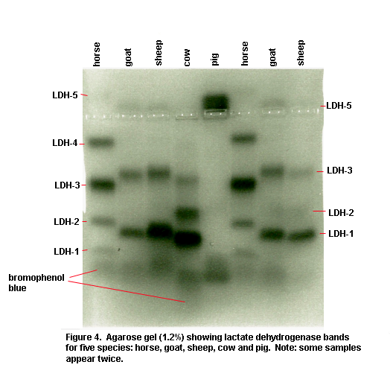

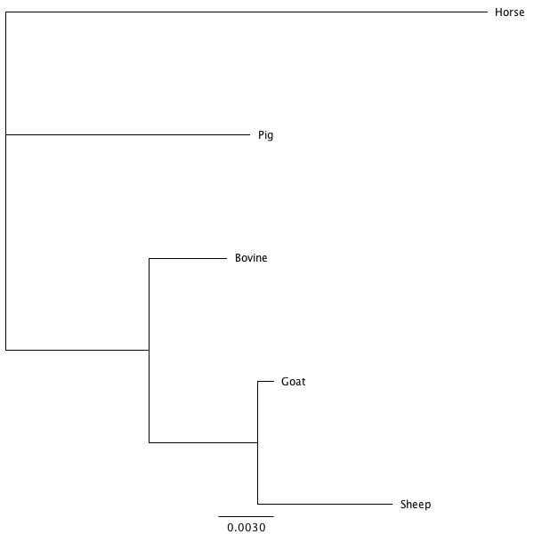

**Figure 4:** Tree of ungulates generated from the protein alignments of LDH chain A sequences using the computer program Geneious and configured according to outlier observations made from both the gel electrophoresis plate and the percent identity matches.

Grading Rubric:

Phylogeny of Ungulates Lab Report

**~~~This report is worth 30 points ~~~**

For Introduction to Biology, you will be required to communicate your results in the form of reports or write-ups for lab, and papers or posters for studio. It is expected that you will effectively communicate your findings using the appropriate biological terms that you have learned. For this Ungulate report, you must include the following terms:

artiodactyl, perissodactyl, unguligrade, tarsals, metatarsals, phalanges, astragulus,

calcaneum, bunodont, selenodont, lophodont, hypsodont, brachydont, incisors, canines,

cheekteeth, omnivore, herbivore, ruminant, non-ruminant, foregut fermenter, hindgut

fermenter, lactate dehydrogenase, isozyme (isoenzyme), amino acid(s), and protein.

The intent of this report is to demonstrate that you understood the theory behind the experiments we did, that you used this information to make reasonable predictions, and that you were able to discuss and interpret your results in light of these predictions. If you performed the experiments and understood the theory, and *cover ALL of the points listed below*, you should do well on the report.

Finally: ***Don’t plagiarize***. *Your lab report should not resemble your partner’s in any way, shape or form.*

**Title (1 pt)**

**Abstract (1 pt)**

**Introduction (1 pt) – What was the goal of this lab?**

Begin by summarizing the relevant information about the ungulates studied in lab, the morphological characteristics that helped you distinguish perissodactyla from artiodactyla and, further, the species that belong to each suborder.

**Hypothesis I (1 pt):** A phylogenetic tree based on morphology/fossil record, not including molecular data.

Additionally, state how molecular information from a comparison of LDH isozymes and pairwise comparisons of macromolecules (e.g., protein sequences) and molecular phylogenies aided in the resolution of the evolutionary relationships of some species that you were not able to resolve using just morphological approaches. Conclude the introduction with a statement of your Hypothesis II about the evolutionary relationships of the ungulates you studied.

**Materials and Methods (0 pts) - What did you do? How did you do it?**

**Results (Text + Figures + Tables = 6+10+6 = 22 pts) - What did you find? Do you have evidence to support/reject your hypothesis?**

There are really two parts to Results:

1) a narrative summary or text (**6 points**) of the results describing what you observed and

2) the supporting tables (**6 points**) and figures (**10 points**).

The tables and figures must be referenced in the text at the end of sentences, and in parenthesis, so that your reader can find them (see example sentence below).

**Example Sentence:** *The results show that bovids are more closely related to goats and sheep than they are to horses and donkeys (Figure 1).*

The text of the results must describe your observations about the following:

**Text (total 6 pts):**

**1) Morphological results (4 pts):**

* dentition (cusps, crown height, and absence of incisors/canines in upper jaw)
* digestive systems (simple, foregut fermenter, or hindgut fermenter)
* headgear structures (horns or antlers)
* foot morphology and locomotion

**2) Molecular results (2 pts):**

* LDH isozyme patterns from the gel – Which species had band patterns that were identical and dissimilar?
* Geneious results: COXIII, LDH, Cytochrome b, and fibrinogen – Which phylogenies gave results that matched and did not match those based on your morphological phylogeny? Look at each Geneious-generated phylogeny carefully and note ambiguities.

Both tables and figures are numbered sequentially, just as they appear in your report.

**Figures (10 pts):** numbered *in sequence as they are described in your report.*  You must include figure legends. Consult with your TA/Instructor and include the following in your report:

* (2 pts) morphological phylogeny (cladogram) based on the derived character table.
* (2 pts) photos of the horse, cow and human feet with the scales. Label and color-code homologous bones
* (2 pts) digital printout or photo of the LDH gel with labels (species and LDH isozymes)
* (2 pts) Geneious-generated molecular phylogenies: COX-III, LDH, cytochrome b and fibrinogen.
* (2pts) phylogenetic tree (cladogram) of what you think **best represents** the relationships of all of the ungulates based on all of your data, both morphological and molecular

**Tables (6 pts):** numbered *in sequence* with a caption**.** Consult with your TA/Instructor and include the following in your report:

* (2pts) derived character table
* (2pts) matrix of shared derived characters
* (2pts) pairwise comparison of LDH sequences to the bovine sequence

**Discussion (2 pts) - What do your results mean?**

Interpret your results, supporting your conclusions with the data you collected. Based on your observations – morphological and molecular – describe which species are most closely related, and which are least closely related. You must justify your conclusions based on the data you collected. For the Geneious-generated phylogenies, you must carefully compare them noting any discrepancies between them. Then, describe which ones most accurately represent what you believe is most representative of the actual relationships between ungulate groups. (Note: You may need to generate new phylogenies with a different out-group. Include a phylogenetic tree (cladogram) of what you think **best** represents the relationships of all of the ungulates based on ALL of your observations from both morphological and molecular data. Is this phylogenetic tree (=Hypothesis II) based on the evidence you collected in lab congruent to Hypothesis I, based on just morphological data?

**Hypothesis II (1 pt)**

**Citations (1 pt)**